10 BENEFITS OF ONLINE SHOPPING AND OFFLINE SHOPPING
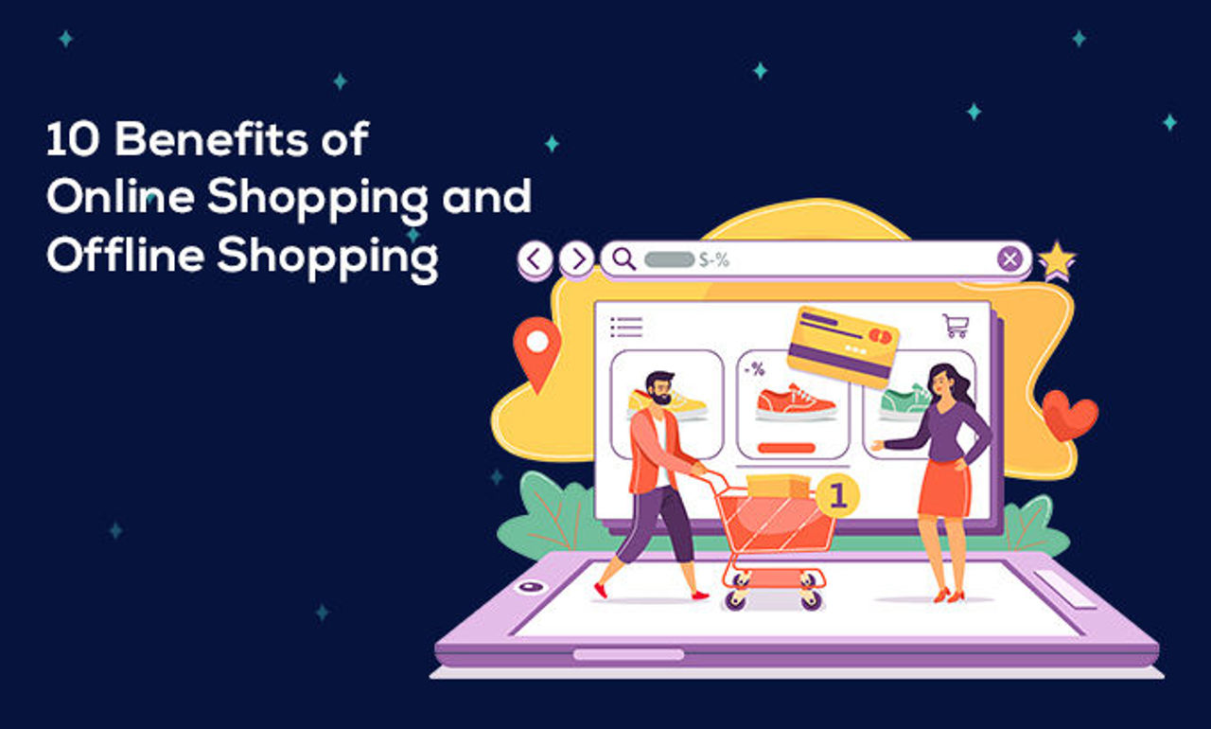
Shopping is always beneficial because every time you shop for something you get something right? Although you get that in exchange for money. But the joy you get while shopping is nothing in the place of money. In this article, we will discuss the 10 benefits of online shopping and offline shopping.
We see two types of shopping naturally. They are online and offline shopping. Offline shopping is the traditional way of shopping being present at the counter or shop or store. While online shopping is buying anything through the internet from your house.

10 Benefits of Online Shopping
Let’s first discuss the 10 benefits you can get from online shopping.

1. Shop from the home
Shopping online gives the best experience of purchasing a thing from home. Without going to the market. Buy anytime from anywhere you prefer.

2. Saves money
With lots of exciting offers, discounts, and coupons online shoppers save money a lot. Also, summer offers, winter offers, and occasion sales are always there. Many gift cards reduce expenses too.

3. More options to choose
Only by navigating web pages of different websites, you can choose your product by reading the reviews carefully and wisely.

4. Easy return and cancel of items
You can cancel any online ordered product or return any purchase if you do not feel they meet your expectation. If you paid for the product then your money will be refunded within some days on your account.

5. No pressure to buy
There is no pressure to buy anything while shopping online. But in offline shopping, you may suffer this. You can select your desired items without any pressurization from the owner or sellers of the store.

6. Low transportation fees
If you need to send or bring large and heavy items to some places or your home. It was a headache. But in online shopping, you do not have to think about it anymore. They will be delivered to your recommended place.

7. Time saver
Standing in a queue for hours to buy something, that era is gone. You do not have to wait outside of any store any longer. You can buy according to your time. Even in the restaurants and cinema halls, you can buy tickets from earlier, so you do not have to wait outside now. Save your precious time and utilize it.

8. Safe from the crowd
In this time of covid, it is very important not to go to any crowded places. These crowds can affect your health. And it can become a cause of pickpocketing too. So, it is safe to shop online without going among the masses.

9. Easy to compare
Open multiple web pages of online stores and compare your products with each other and with multiple other options. Read and watch reviews see how they are compared and decide which one to buy.

10. Multiple payment options
Another important feature of online shopping is you can access many options for payment. Cards, UPI, QR code payments, internet banking, and many other options are available for payment online. You can choose a cash-on-delivery option too if you do not feel safe with internet payment options.

10 Benefits of Offline Shopping
Do not think that offline shopping has only demerits, it has its own merits too. We have discussed it in the following.

1. No time delivery
Go to the store and get what you want without delay in offline shopping. You do not have to wait for 5 to 7 days for getting the product, which happens with online shopping.

2. Choose by experience
Choose any product with your personalized experience. Touch and feel the product, know how it is then buy if you want or not. Online shopping does not give you this option.

3. Quick return
Returning any product is easy in offline shopping as getting the product without delay. Go to the store on the day they take the return and return or exchange the product immediately.

4. Satisfaction of shopping
As I stated earlier, getting satisfaction while shopping with friends or family or your loved one is different. You can never get that satisfaction or joy in online shopping.

5. Personalized recommendation from the staff
When you shop online it takes much time to research before buying any product. But when you shop offline, some staff handle plenty of customers each day and know what will suit them. So you can get personalized recommendations from them before buying anything recklessly.

6. Purchase immediate products
Your daily and immediate needs like vegetables, medicines serve the offline shopping, just go and buy them immediately.

7. Pay by cash or other options
It has been seen in many stores that they are providing the opportunity to pay by cash or other options like cards, QR codes, UPI, etc. this allows people to buy more offline.

8. Safety
In electronic payments, your cash may be stuck, or not paid in time. This give-and-take policy is much more transparent than online payments.

9. Size and fitting
Choose items according to your size and fitting. If needed you can give trials in many shopping stores then buy with satisfaction.

10. People without much knowledge of the digital world can visit
Many people in this world, mainly rural and illiterate, do not get access to the mobiles or internet. So, shopping offline is the best option for them to have the things they want without facing any problems.

Wrap Up
Wherever you shop, either online or offline, you need to be alert in each case. There are different types of problems you might be facing in both the cases of online and offline shopping.

